SESSION AUG/SEP 2022
PROGRAM BACHELOR OF BUSINESS ADMINISTRATION (BBA)
SEMESTER IV
COURSE CODE &amp; NAME DBB2203 &amp; MANAGEMENET ACCOUNTING
CREDITS 4
1. “Management Accounting collect, analyses and presents the accounting information in such a way as to assist the management in the creation of policy and in day-to day operations of an undertaking”. Elucidate.
Ans: Management Accounting, in simple words, may be referred to as the accounting that helps the managers. This is management-oriented accounting. The accounting activity is reoriented to help the managers in their day-to-day tasks and functions. The basic aim of Management Accounting is to help with the operational requirements of the firm. Management Accounting maintains past and present records systematically so that the managers utilize the information
Its Half solved only
Buy Complete from our online store

https://smuassignment.in/online-store/

MUJ Fully solved assignment available for session Jul/Aug 2022, Exam Sep 2022.

Lowest price guarantee with quality.
Charges INR 200 only per assignment. For more information you can get via mail or Whats app also
Mail id is aapkieducation@gmail.com

Our website www.smuassignment.in
After mail, we will reply you instant or maximum
1 hour.
Otherwise you can also contact on our
whatsapp no 8791490301.

2. From the following forecast of income and expenditure, prepare a Cash budget for three months ending on June, 2021
Month | Sales(Rs.) | Purchases (RS.) | Wages(Rs.) | Misc.(Rs.)
February | 120000 | 84000 | 10000 | 7000
March | 130000 | 100000 | 12000 | 8000
April | 80000 | 104000 | 8000 | 6000
May | 116000 | 106000 | 10000 | 12000
June | 88000 | 80000 | 8000 | 6000

Additional Information:
1. Sales: 20% realised in the month of sales, discount allowed 2%, balance realised equally in two subsequent months
2. Purchases: These are paid in the month following the month of supply.
3. Wages: 25% paid in arrears following month
4. Misc. expenses: Paid a month in arrears
5. Rent: Rs.1000 per month paid quarterly in advance due in April.
6. Income Tax: First instalment of advance tax of Rs.25000 due on or before 15 th June to be paid within the month
7. Income from investment: Rs.5000 received quarterly in April, July etc.
8. Cash in hand: Rs.5000 on 1st April 2021
Solution: Cash Budget April - June 2012
Particulars | April Rs. | May Rs. | June Rs.
Opening Balance | 5,000 | 6,000 | 6,300
Debtors Realised | 1.16,000 | 1.07,200 | 96,000

3. The following are the balance sheet of ABC ltd. for the years 2020 and 2021. Prepare a comparative Balance sheet and comment on the financial position of the company
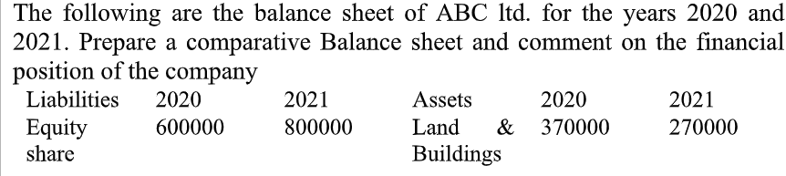
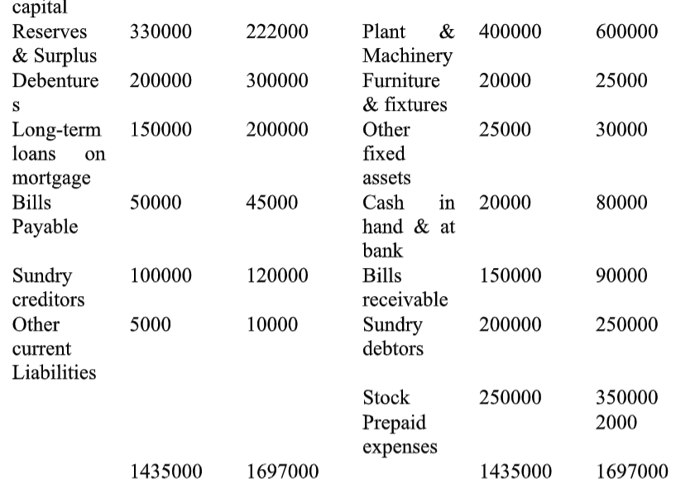

Assignment Set – 2

4. Ratio analysis is widely used as a tool of financial analysis, yet it suffers from various limitations. Explain the importance and limitations of ratio analysis using examples wherever suitable.
Ans: It helps to compare items found in financial statements with other items. For example, an item of net profit would make sense, when it is not considered in isolation, which means that it should be compared with the capital invested in the business. Current assets and current liabilities
5. A chemical company is considering investment in a project that costs Rs.500000. The life of the project is 5 years and estimated salvage value is zero. Tax rate is 55%. The company uses straight line depreciation and proposed project has earnings before depreciation and before tax as follows:
Year | Earnings before depreciation & tax (Rs) | PV factor @15%
1 | 1,00,000 | 0.870
2 | 1,00,000 | 0.756
3 | 1,50,000 | 0.658
4 | 1,50,000 | 0.572
5 | 2,50,000 | 0.497

Calculate the following: -
1. Payback period
2. Average rate of return if po
3. Net present value @15%
6. Prepare cash flow statement from the following Balance sheet as on 31st March 31, 2021
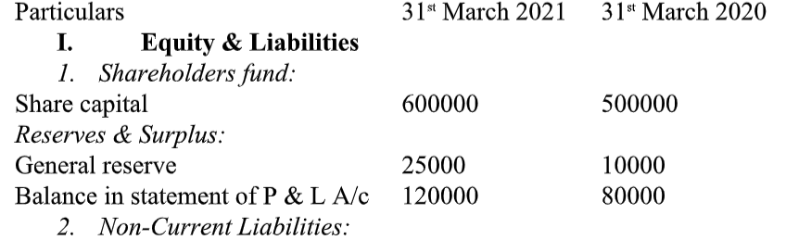
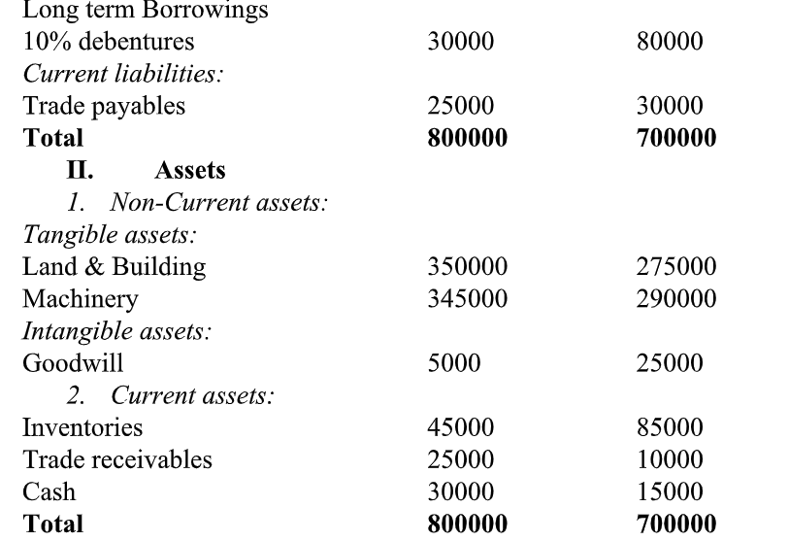
Adjustment:
1. Depreciation provided on machinery during the year Rs.12000
2. New shares issued on 31st March 2021
3. 10% debentures were redeemed on 31st March 2021

