SESSION AUG/SEP 2022
PROGRAM MASTER OF BUSINESS ADMINISTRATION (MBA)
SEMESTER III
COURSE CODE &amp; NAME DBFI302 – FINANCIAL STATEMENT ANALYSIS AND BUSINESS VALUATION

Assignment Set – 1
1. What are the objectives and purpose of conceptual framework of IASB?
Ans: The objectives of IASB (formerly known as IASC) which are set out in its revised agreement and constitution are:
1. To formulate and publish in the public interest, International Accounting Standards (IASs) to be observed in the presentation of financial statements and to promote their worldwide acceptance and observation; and
2. To work for the improvement and harmonisation of regulation accounting standards and procedures relating to the presentation Its Half solved only
Buy Complete from our online store

https://smuassignment.in/online-store/

MUJ Fully solved assignment available for session Jul/Aug 2022, Exam Sep 2022.

Lowest price guarantee with quality.
Charges INR 200 only per assignment. For more information you can get via mail or Whats app also
Mail id is aapkieducation@gmail.com

Our website www.smuassignment.in
After mail, we will reply you instant or maximum
1 hour.
Otherwise you can also contact on our
whatsapp no 8791490301.

2. Explain different types of earning ratios.
Ans: Valuation Ratios or Earning Ratios generally, valuation or earnings ratios are calculated using a company's current share price and reveal whether the stock is a good investment at the time. Because they assess a company's stock market attractiveness, these ratios are also known as market ratios.
The following are some

3. Explain the divisions of cash flow statement.
Ans: The cash flow statements have three basic classifications:
1. Cash flow from operating activities
2. Cash flow from investing activities and
3. Cash flow from financing

Assignment Set – 2
4. Explain the effect of leverage on operating and finance activities.
Ans: Effect of leverage on operating and financing activities Businesses use leverage to increase assets, cash flows, and returns, but it can also magnify losses. Financial and operational leverage are the two types of leverage. A company's financial leverage can be increased by

5. Explain the evaluation of P/E ratio
Ans: 1. Evaluation of P/E ratio includes:
a) High P/E Ratio: Growth stocks are companies that have a high P/E ratio. For investors, a high P/E ratio may be a sign of future success and rising profitability. On the other hand, growth stocks have a high level of
6. A Ltd produces its balance sheet on 31 March 2021 and requests its business professional appraiser to evaluate the value of business based on Asset Based Valuation Method. Assuming you are a business professional appraiser, evaluate the Company A as on 31 March 2022.
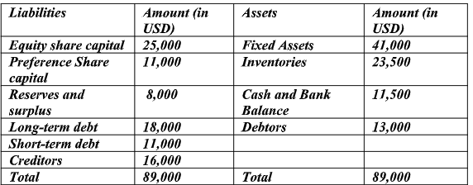
Solution: Asset Based Valuation Method takes into account company's total net asset value less the value of its total liabilities as shown on its balance sheet. Thus, the valuation of Company A as follows:

