SESSION DEC 2022
PROGRAM BACHELOR OF COMMERCE (B COM)
SEMESTER III
COURSE CODE &amp; NAME DCM2103 Cost Accounting
CREDITS 4

Set – 1

1. a. Discuss the functional classification of cost.
Ans: Overheads based on functions are classified as:
a) Manufacturing Overheads: all indirect expenses incurred at the factory or for manufacturing process are grouped as manufacturing overheads
E.g., factory rent, electricity charges, heating and lighting charges, etc.
b) Administrative Overheads: indirect expenses incurred for running the business like office staff salaries, office
Its Half solved only
Buy Complete from our online store

https://smuassignment.in/online-store/

MUJ Fully solved assignment available for session Jul/Aug 2022, Exam Sep 2022.

Lowest price guarantee with quality.
Charges INR 200 only per assignment. For more information you can get via mail or Whats app also
Mail id is aapkieducation@gmail.com

Our website www.smuassignment.in
After mail, we will reply you instant or maximum
1 hour.
Otherwise you can also contact on our
whatsapp no 8791490301.

2. The following information is in respect of Material
Re-order quantity = 1500 units
Re-order period = 4 – 6 weeks
Maximum Consumption = 400 units per week
Normal consumption = 300 units per week
Minimum consumption = 250 units per week
Emergency Re- order period = 2 weeks
Calculate:
(a) Re-order level
(b) Minimum Level
(c) Maximum Level
(d) Average stock level
(e) Danger Level
Solution: Given:
Reorder quantity = 1500 units
Maximum units = 400
Normal units =

3. a. Discuss the behavioural classification of overhead.
Ans: The classification of overhead cost is based on four main characteristics given as follows:
I. Classification based on Elements:
Similar to the elements of costs that we have already discussed in the previous units, elements are:
a) Indirect Material (e.g., small tools, lubricants, coolants, cleaning material, etc.)
b) Indirect

Set – 2

2. a. Explain the importance of cost accounting.
Ans: For any enterprise in any industry a cost accounting system is very much necessary. However, it carries more importance in the manufacturing industry. Cost accounting to a manufacturing industry is like a network of nerves in the human body. It’s a must for the survival of the organization in this competitive world. The Cost Accounting system is vital for the manufacturing industry as the product cost can be correctly arrived, only if cost records are properly

b. A manufacturer of a food preserver produces two grades of the product involving 2 distinct processes of manufacture. The identical units are introduced in process A and the entire output is transferred to process B. From the following particulars prepare the relevant process accounts.

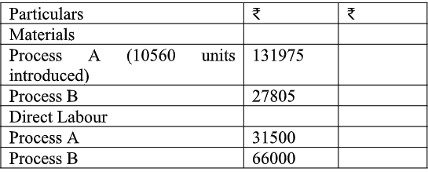
There was no opening or closing stock in process A and process B. Works overheads are absorbed @ 40% of Direct labour in all processes. There were no spoiled units in any process.
Ans:

3. A. What is operating costing explain its any 3 types of operating cost
Ans: According to Weldon, “Operating costing is a unit costing as applied to the cost of services”
According to CIMA, London, “Operating Costing is that form of operation costing which applies where
b. Explain any 5 reasons for differences in profit as per costing records and financial records
Ans: Abnormal items as abnormal wastage of material by theft, wages of abnormal idle time, cost of abnormal idle facilities, exceptional bad debts, and abnormal gain on manufacturing may be shown in financial

