SESSION DEC 2022
PROGRAM BACHELOR OF COMMERCE
SEMESTER III
COURSE CODE &amp; NAME DCM2105– FINANCIAL STATEMENT INTERPRETATION
CREDITS 4

1. “Analysis without interpretation is meaningless and interpretation without analysis is impossible”. In light of the above statement, Discuss concept and significance of financial statement analysis.
Ans: Interpretation means explaining the meaning and significance of the data. These two are complimentary to each other, analysis is useless without interpretation, and interpretation without analysis is difficult or even impossible.
Financial statement
Its Half solved only
Buy Complete from our online store

https://smuassignment.in/online-store/

MUJ Fully solved assignment available for session Jul/Aug 2022, Exam Sep 2022.

Lowest price guarantee with quality.
Charges INR 200 only per assignment. For more information you can get via mail or Whats app also
Mail id is aapkieducation@gmail.com

Our website www.smuassignment.in
After mail, we will reply you instant or maximum
1 hour.
Otherwise you can also contact on our
whatsapp no 8791490301.

2. Explain the components of the Income statement as per the revised Schedule III of the Companies Act 2013.
Ans: Schedule III – Companies Act, 2013 Schedule III of the Companies Act, 2013 specifies how every company registered under the Act must prepare its Statement of Balance Sheet, Income Statement or Profit and Loss Statement and Financial Statement Notes.
General Instructions

3. Prepare a schedule for changes in the working capital from the Balance Sheet data given below:
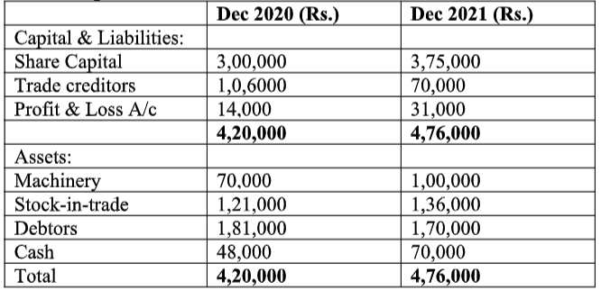
Ans:

Assignment Set – 2

4. The following figures are extracted from the books of XYZ ltd. as at 30-6-2021
Net sales  Less Cost of goods sold  Gross Profit  Net Profit  Current assets  Inventories  Fixed assets  Total assets  Net worth  Debt  Current Liabilities  Total Liabilities  Working Capital | 24,00,000  18,00,000  6,00,000  3,60,000  7,60,000  8,00,000  14,40,000  30,00,000  15,00,000  9,00,000  6,00,000  30,00,000  9,00,000

Calculate:
1. Gross profit ratio
2. Net Profit ratio
3. Inventory turnover ratio
4. Working capital turnover ratio
Ans:

5. What do you mean by Annual Report? Explain the constituents of the annual report.
Ans: An annual report is a detailed report on a company's operations during the previous year. Annual reports are intended to inform shareholders and others who are interested in the company's activities and financial performance. They could be classified as grey literature. The majority of

6. From the following Balance sheet of a concern for the years 2021 and 2022. Prepare a comparative Balance sheet and comment on the financial position of the concern:
Liabilities | 2021 | 2022 | Assets | 2021 | 2022
Equity Share capital | 6,00,000 | 8,00,000 | Land &amp; Buildings | 3,70,000 | 2,70,000
Reserves &amp; Surplus | 3,30,000 | 2,22,000 | Plant &amp; machinery | 4,00,000 | 6,00,000
Debentures | 2,00,000 | 3,00,000 | Furniture &amp; Fixtures | 20,000 | 25,000
Long-term loans on mortgage | 1,50,000 | 2,00,000 | Other fixed assets | 25,000 | 30,000
Bills payable | 50,000 | 45,000 | Cash in hand and bank | 20,000 | 80,000
Sundry creditors | 1,00,000 | 1,20,000 | Bills receivable | 1,50,000 | 90,000
Other current Liabilities | 5,000 | 10,000 | Sundry Debtors | 2,00,000 | 2,50,000
 |  |  | Stock | 2,50,000 | 3,50,000
 |  |  | Prepaid Expenses |  | 2,000
 | 14,35,000 | 16,97,000 |  | 14,35,000 | 16,97,000

Ans:

