|  |  |
| --- | --- |
| **SESSION** | **MARCH-2023** |
| **PROGRAM** | **Master of business administration (mBA)** |
| **SEMESTER** | **III** |
| **course CODE & NAME** | **dmkt301 &sales distribution &supply chain management** |
| **CREDITS** | **4** |
| **nUMBER OF ASSIGNMENTS & Marks** | **02**  **30 Marks each** |

**Assignment Set – 1**

**1. What is sales Management? Explain its importance.**

**Ans 1.**

**Sales Management**

In the words of Rachman and Romano, "Sales Management includes recruiting, selecting, training, supervising, motivating and evaluating the salesforce."

According to B.R. Canfield, "Sales Management involves the direction and control of salesmen, sales planning, budgeting, policymaking, coordination of marketing research, advertising, sales promotion and merchandising and the integration in the marketing

Its Half solved only

Buy Complete from our online store

<https://smuassignment.in/online-store/>

MUJ Fully solved assignment available for**session March 2023.**

Lowest price guarantee with quality.

Charges**INR 200 only per assignment.**For more information you can get via mail or Whats app also

Mail id is [aapkieducation@gmail.com](mailto:aapkieducation@gmail.com)

Our website www.smuassignment.in

After mail, we will reply you instant or maximum

1 hour.

Otherwise you can also contact on our

whatsapp no 8791490301.

**2. Write Short notes on:**

**Ans 2.**

**A. Role of Sales Manager.**

The role of a sales manager is pivotal to the success of any business; they serve as the link between the sales team and the company’s management, aligning the company's strategy with its execution. This multifaceted position entails various responsibilities, encompassing leadership, coordination, strategy, and planning.

At its core, the sales manager's role is to lead and guide the sales team. They are responsible

**3. Explain different types of Wholesalers.**

**Ans 3.**

Wholesalers go by a variety of names and perform a variety of tasks. They are classified into three groups.



**Types of Wholesalers**

1. Merchant wholesalers

2. Brokers and agents

3. Manufacturers’ sales branches and offices

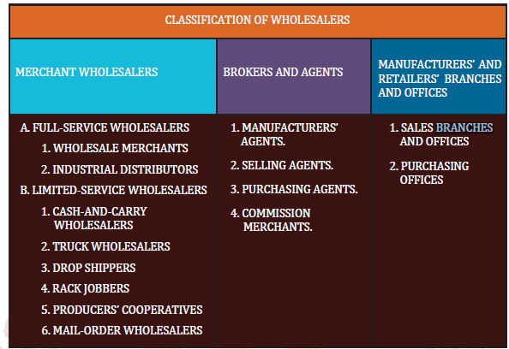

**1. Merchant Wholesalers**

**Assignment Set – 2**

**1. What is Horizontal Market System? Explain its Components.**

**Ans 1.**

**Horizontal Market System**

A horizontal marketing system is a form of distribution channel in which two or more unrelated companies at the same level join forces to achieve economies of scale. In other words, a horizontal marketing system is the product of the merger of two separate businesses seeking to capitalise on market opportunities. This marketing system is typically used by businesses that lack money, human resources, manufacturing processes, and marketing

**2. Explain the forms of Supply Chain.**

**Ans 2.**

A supply chain is a network of interconnected businesses involved in the ultimate provision of product and service packages required by end customers. The supply chain encompasses all activities associated with the flow and transformation of goods from the raw materials stage, through to the end user, as well as the associated information flows. Below are the four

**3. What are the tools of inventory Management? Explain any 2 of them in detail.**

**Ans 3.**

Inventory management tools help to reduce inventory, ensure smooth flow along the supply chain, and optimises cost. Some popular tools of inventory management are as below.

**MRP--Materials Requirement Planning**

MRP stands for Materials Requirement Planning, and it is computer software that determines